**Project Title: Iguana Patrol**

Team Name: Iguana Squad

Project Roles:

Michael - Project Manager/Owner

Bilal - Software Developer

Alanis - Business Analyst

Francisco - Scrum Master

Nicole - Systems Tester

Dernard - Quality Analyst

Meeting Dates:

1. Brainstorming Ideas: Jan 17, 2022 07:00 PM, Monday
2. Forming a draft: Jan 19, 2022 07:00 PM, Wednesday
3. Working on the draft: Jan 20, 2022 07:00 PM, Thursday
4. Finalizing our draft: Jan 22, 2022 09:30 AM, Saturday (All present minus Bilal)

Short Summary:

We used Miro as the visual collaboration platform to put our ideas on display. During our first meeting, we met up on Zoom and brainstormed ideas for our project as well as selected roles. After selecting a project, we began forming a draft that includes the project description. We decided on the group project name “Iguana Patrol” and continued working on the deliverables, started the UML object diagram, and created the Github repository by the third meeting. We completed the short summary of our project, and discussed the UML diagram and one-page summary to make sure everything is cohesive and added the classes to the GitHub repository on the fourth meeting.

Some of the methods we considered to remove the iguanas:

* Spraying mechanism: The robot dog could spray the iguana with a liquid that naturally repels the animal, such as garlic or neem oil if it detects it at a certain distance.
* Shooting pellets: The robot could shoot out pellets at vital points in the iguanas.
* Noise: The iguanas could be scared off by a sound the robot produces that is sensitive to their hearing.
* Laser Deterrent: The robot could shoot out lasers to repel the iguanas.

More details can be found in our Miro board:

<https://miro.com/welcomeonboard/cVU2UmRJNjJ4N29oaDhFb3E3MTRKckR6cnpiUjRxREFCR0F6b3ozVXphUjFnRW1RTkFMa2NrQ3JIa0xyZ24xVHwzNDU4NzY0NTE2Njk3NTk5NTc4?invite_link_id=62768575329>

**Project Proposal**

Problem Statement:

Green iguanas are an invasive species in South Florida and as a result, pose a serious threat to Florida ecosystems. They consume native plants and crops, damage infrastructures, leave excrements everywhere, and can carry salmonella. With the landowner's permission, it is legal to exterminate iguanas on private property as long as it is without cruelty and it dies instantly.

Solution:

The Iguana Patrol project is intended to control the population of invasive green iguanas in South Florida private properties. To combat this issue, our team proposes to utilize a system designed to safeguard private properties from iguanas. The robot will use facial recognition technology to identify iguanas and will be programmed to chase the animals away from the premise.

Design:

* Form: The robot dog will have a body that has four legs and contains the circuit board within it. On top of the body will be a rectangular LED Display. A head will be connected to the body.
* Control Methods: The kit will contain an IR remote to control the robot. The robot is also designed to connect to Bluetooth so a user will be able to control it wirelessly with other devices (Android phone or tablet, iPhone, and computer).
* Cameras: A group of cameras could be connected to the robot.

Features:

* Laser Deterrent: The robot will shoot out lasers to repel the iguanas.
* Horn: When an iguana is detected, the robot dog will produce a sound with a horn to scare off the animal.
* Ultrasonic Module: This module is used for obstacle avoidance.
* Gait: The robot will be able to move forward, backward, and turn left and right like a real dog.
* Animal recognition: The robot will be programmed to detect iguanas using facial recognition using a camera that will capture and record footage and detect movement.
* LED display: The LED display on top of the robot dog can change colors and animation.

**UML Object Diagram Draft**

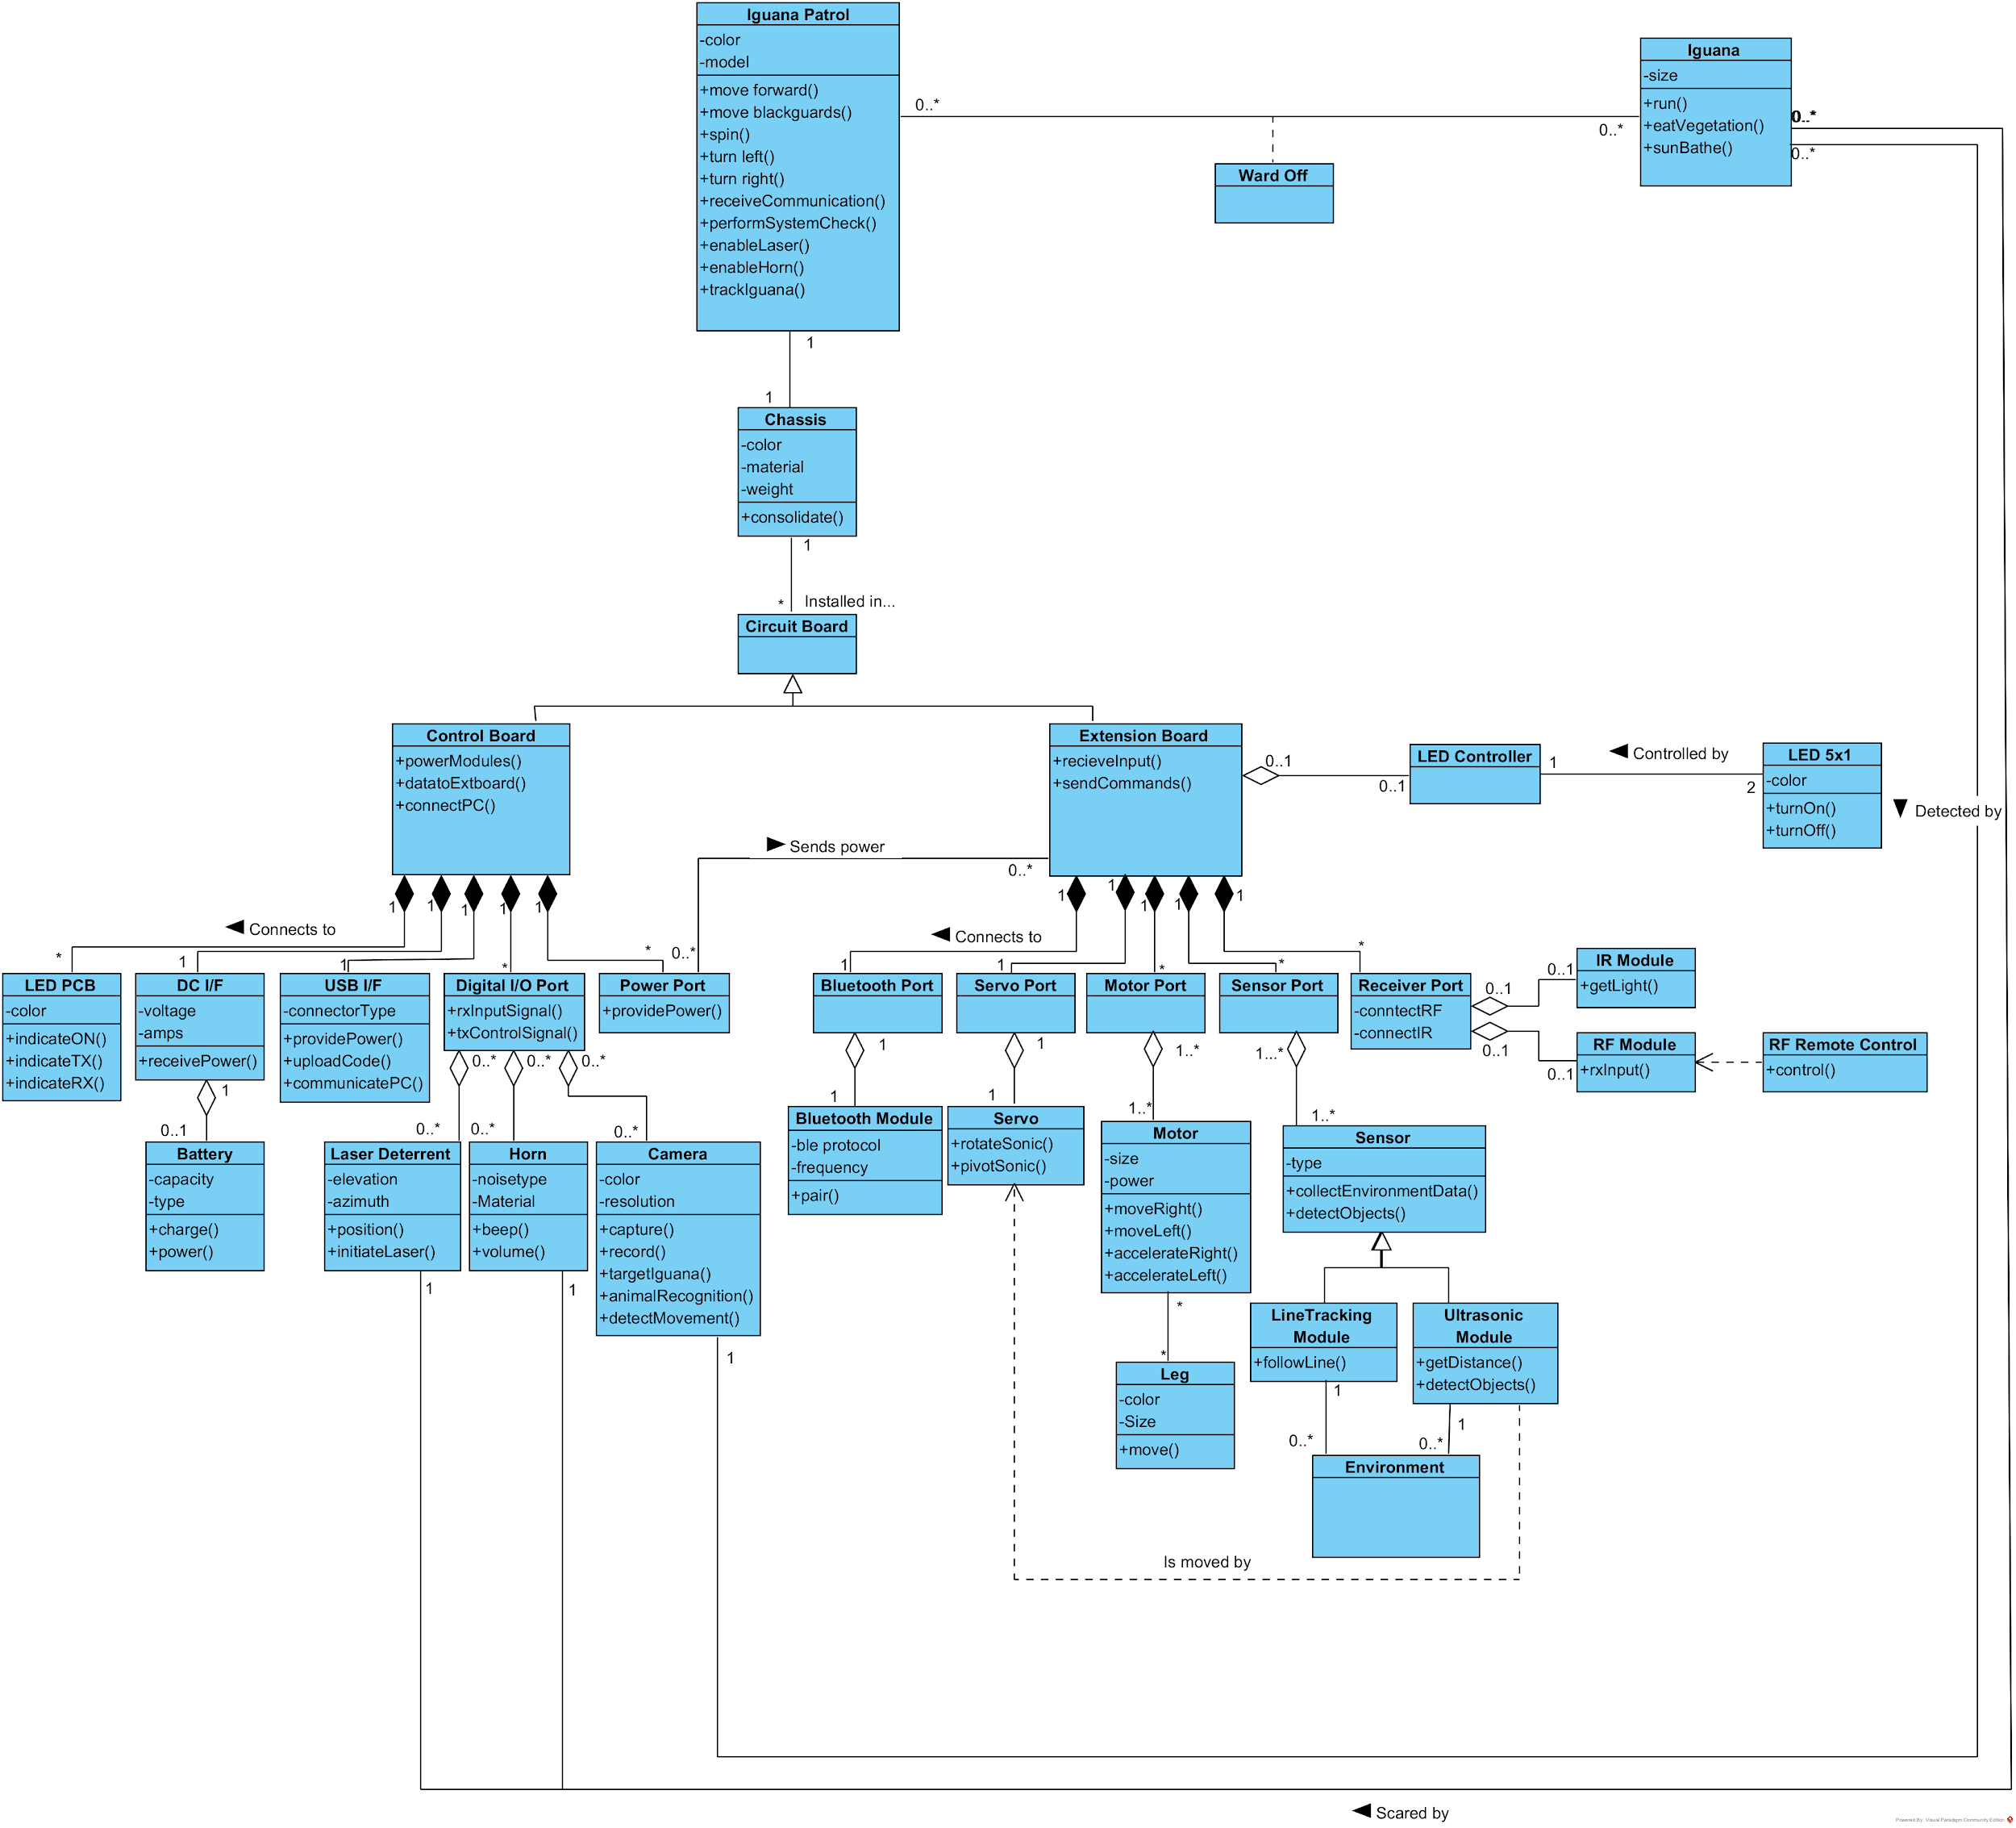

Github link:

<https://github.com/mlaroccaFIU/IguanaPatrol>